

CAPSTONE PROJECT REPORT
Report 5 – Software Test Documentation

– Hanoi, Jan 2025 –
Table of Contents
I. Record of Changes 3
II. Testing Documentation 4
1. Scope of Testing 4
1.1 Scope 4
1.2 Included ModulesThe following modules are included in the testing scope: 4
1.3 Excluded Scope 5
2. Test Strategy 5
2.1 Testing Types 5
2.2 Test Levels 6
2.3 Supporting Tools 6
3. Test Plan 7
3.1 Human Resources 7
3.2 Test Environment 7
3.3 Test Milestones 8
4. Test Cases 9
5. Test Reports 9
5.1 Unit Test 9
5.2 Integration Test 10
5.3 System Test 10
5.4 Acceptance Test 10

I. Record of Changes
Date | A*  M, D | In charge | Change Description
27/02/2026 | A | LinhVTK | Add Scope of Testing, Test Strategy, Test Plan
07/03/2026 | M | LinhVTK | Modify Test Milestones
19/03/2026 | A | LinhVTK | Add Test Reports
16/04/2026 | M | LinhVTK | Modify Test Reports
*A - Added M - Modified D - Deleted

II. Testing Documentation

1. Scope of Testing

1.1 Scope
Testing activities for the Nova Learning Management System (Nova LMS) aim to ensure that all major system functiona
lities operate correctly, reliably, and meet the business requirements for online English course management and learning. The testing scope focuses primarily on validating system workflows, user interactions, data management, and role-based access control across different user roles. Testing will mainly involve functional testing, system testing, and user acceptance testing to ensure that the system is stable and usable before deployment.

1.2 Included ModulesThe following modules are included in the testing scope:
User Management
- User Registration
- Login / Logout
- Password Reset
- User Profile Management
- Role-based Access Control (Guest, Student, Teacher, Expert, Manager, Admin)
Course Management
- Create Course
- Update Course
- View Course List
- Public Course Viewing
- Course Details
Class Management
- Create Class
- Update Class
- Class Enrollment
- Public Class Viewing
- Class Details
Placement Test Module
- Placement Test Registration
- Placement Test Execution
- Placement Test Results
Learning Management
- Student course enrollment
- View course progress
- Access course materials
Administration Module
- Manage users
- Manage courses
- Manage classes
- Monitor system activities

1.3 Excluded Scope
The following items are not included in the current testing scope:
- Third-party payment gateway integrations (if applicable)
- External email delivery services
- Infrastructure-level performance testing (cloud scaling)
- Mobile application testing (if mobile app is not part of MVP)

2. Test Strategy

2.1 Testing Types
Test Type | Objective | Technique | Responsible Role
Unit Testing | Verify individual components and functions | Code-level testing | Developers
Integration Testing | Verify communication between modules | API & data flow testing | Developers
System Testing | Validate complete workflows of Nova LMS | Scenario-based testing | Tester / BA
Manual Testing | Verify UI functionality and usability | Functional testing | Tester
User Acceptance Testing (UAT) | Validate system against business requirements | Exploratory testing | BA / Supervisor

2.2 Test Levels
Type of Tests | Unit | Integration | System | Acceptance
Unit Testing | X
Integration Testing |  | X
System Testing |  |  | X
Manual Testing |  | X | X | X
User Acceptance Testing |  |  |  | X

2.3 Supporting Tools
Purpose | Tool | Vendor / In-house | Version
Unit Testing | Jest / VS Code | Vendor | Latest
Integration Testing | Manual Testing | In-house | Latest
System Testing | Manual Testing | In-house | Latest
Test Case Management | Google Sheets | In-house | Latest
Bug Tracking | Google Sheets | In-house | Latest
Performance Testing | Apache JMeter | Vendor | Latest
Web Browser Testing | Chrome | Vendor | Latest

3. Test Plan

3.1 Human Resources
Worker/Doer | Role | Responsibilities
DatMN | Project Manager | Manage the overall project schedule, coordinate development and testing activities, and ensure project milestones are achieved.
LinhVTK | Business Analyst / Tester | Define testing scope, design test cases, perform manual and system testing, validate business requirements, and support User Acceptance Testing (UAT).
AnhDHD | Front-end Developer | Develop and maintain the user interface of Nova LMS, support UI bug fixing, and assist with integration testing related to frontend components.
ThanhMC | Back-end Developer | Implement backend services, APIs, and database logic, support integration testing, and fix backend defects identified during testing.
TuNC | Back-end Developer | Develop and maintain backend APIs, support system integration, and assist in debugging and resolving system-level issues during testing.

3.2 Test Environment
Purpose | Tool | Provider | Version
Web Application Testing | Google Chrome | Vendor | Latest
Test Case Management | Google Sheets / Excel | In-house | Latest
Bug Tracking | Google Sheets | In-house | Latest
Backend Testing Environment | Nova LMS Staging Server | In-house | Same as development build
Unit Testing | Jest / VS Code | Vendor | Latest

3.3 Test Milestones
Milestone Task | Start Date | End Date
Test Plan & Test Case Preparation | 09/02/2026 | 12/02/2026
Implementation Iteration 1
Unit Testing – Iteration 1 | 23/02/2026 | 25/02/2026
Integration Testing – Iteration 1 | 26/02/2026 | 03/03/2026
Bug Fixing & Regression – Iteration 1 | 04/03/2026 | 06/03/2026
Implementation Iteration 2
Unit Testing – Iteration 2 | 07/03/2026 | 09/03/2026
Integration Testing – Iteration 2 | 10/03/2026 | 15/03/2026
Bug Fixing & Regression – Iteration 2 | 16/03/2026 | 18/03/2026
Implementation Iteration 3
Unit Testing – Iteration 3 | 19/03/2026 | 22/03/2026
Integration Testing – Iteration 3 | 23/03/2026 | 28/03/2026
Bug Fixing & Regression – Iteration 3 | 29/03/2026 | 31/03/2026
System Testing & Regression Testing | 01/04/2026 | 05/04/2026
User Acceptance Testing (UAT) | 06/04/2026 | 10/04/2026
Final Test Report & Test Closure | 11/04/2026 | 13/04/2026

4. Test Cases
- Unit Test: Report 5.1_Unit Test
- Integration Test: Report 5.2_Integration Test
- System Test: Report 5.3_System Test
- Acceptance Test: Report 5.4_Acceptance Test

5. Test Reports

5.1 Unit Test
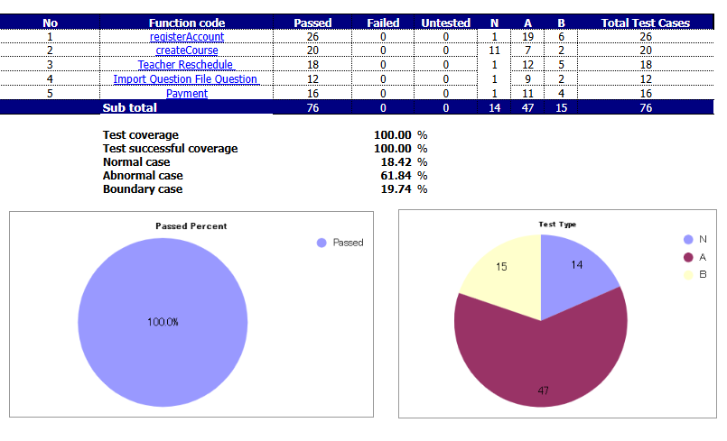

5.2 Integration Test
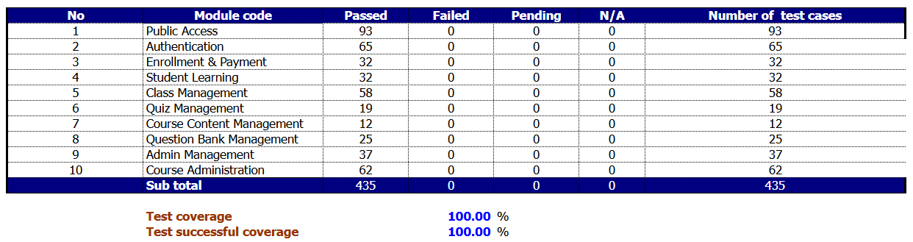

5.3 System Test
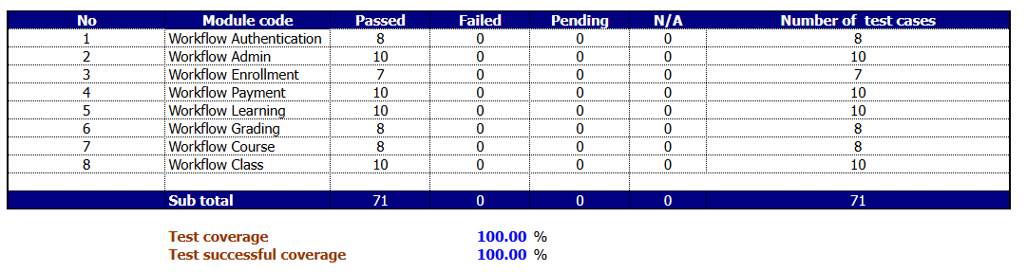

5.4 Acceptance Test
